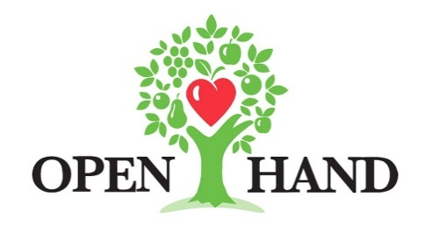

FOR MORE INFORMATION:
Brianna Poplaskie
BRAVE Public Relations
404.233.3993
bpoplaskie@emailbrave.com

**MEDIA ADVISORY / VISUAL AND INTERVIEW OPPORTUNITIES**

Dining Out For Life Kick-Off Event with Project Runway’s Mondo Guerra, April 25
National Dining Out For Life spokesperson Mondo Guerra to discuss HIV journey and present Open Hand Atlanta with custom artwork

ATLANTA (April X, 2022) – As part of its annual fundraiser Dining Out For Life, Open Hand Atlanta welcomes national Dining Out For Life spokesperson Mondo Guerra of Project Runway fame for an art unveiling and Q&A on Monday, April 25 from 4 p.m. – 6 p.m. at Guac y Margys Midtown. Mondo is an advocate of HIV awareness who has been vocal about the cause since his days on Project Runway. He continues to raise awareness through other artistic works and programs such as Dining Out For Life, which returns to Atlanta on April 27.

During this Q+A Mondo will discuss his personal journey of living with HIV, the importance of support for those living with HIV from organizations like Open Hand, as well as how he uses his designs to support the cause. Along with this discussion, he will unveil a new art piece depicting his story in the same vein as his Pozitivity design that sparked interest during his Project Runway run. Through this event and his time in Atlanta with Open Hand, he hopes to further his mission of HIV awareness, as well as highlight the importance of volunteerism in supporting the mission of Open Hand Atlanta, with a particular focus on the HIV-affected community.

WHAT: Art Unveiling + Q&A

WHEN: Monday, April 25, 2022
4 p.m. – 6 p.m.

WHERE: Guac y Margys
502 Amsterdam Ave NE
Atlanta, GA 30306

HOW: This event is open to media and guests of Open Hand only. It is not open to the public. Please RSVP to Brianna Poplaskie at bpoplaskie@emailbrave.com or 404.233.3993.

For more information on Dining Out For Life and Open Hand, as well as to stay up-to-date on events and volunteer opportunities, please visit diningoutforoh.org and openhandatlanta.org or connect via Facebook, Twitter and Instagram.

###

